**Name: Amey Anil Mhadgut**

**Roll number: 220340520019**

**Centre: CDAC Juhu**

**Sub.: SDM Module Exam**

**Date:22.08.2022**

[**https://testmoz.com/q/12087536**](https://testmoz.com/q/12087536)

**019-amey-jh-bucket**

**MCQ**



**Question 2**

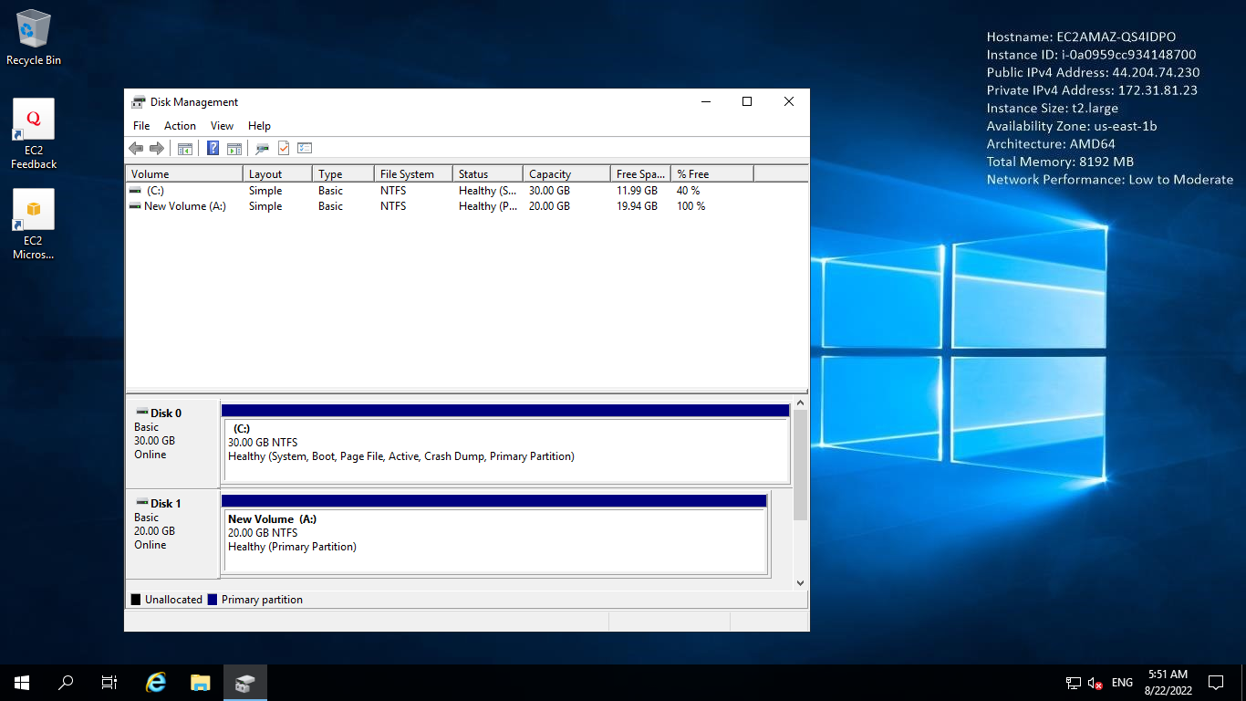

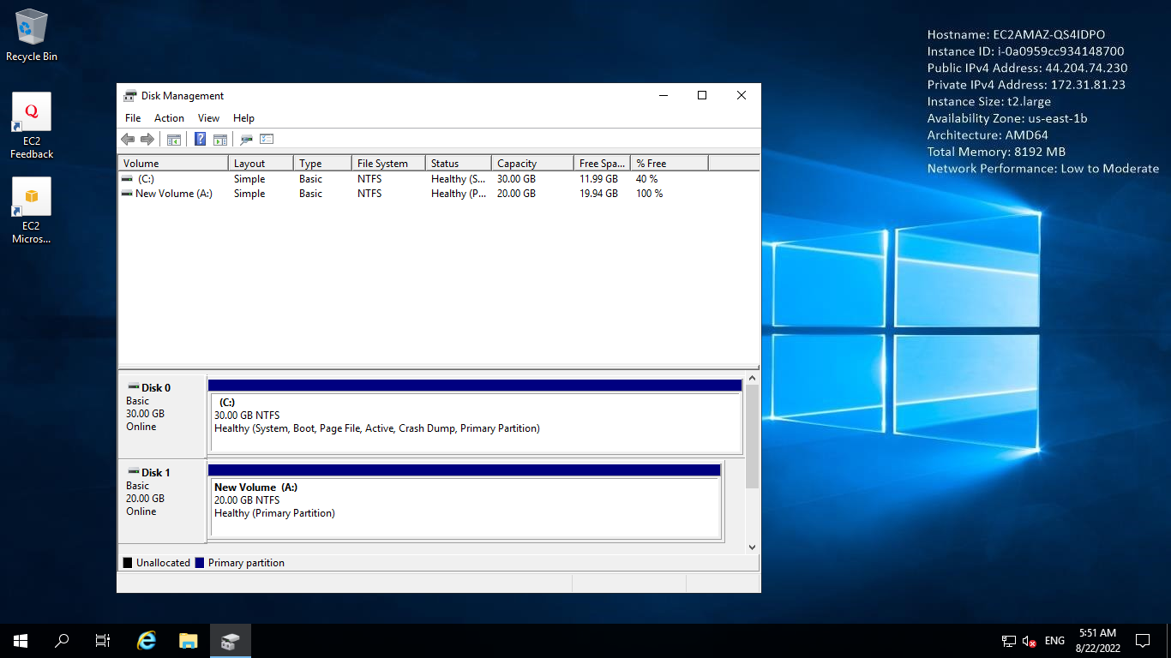

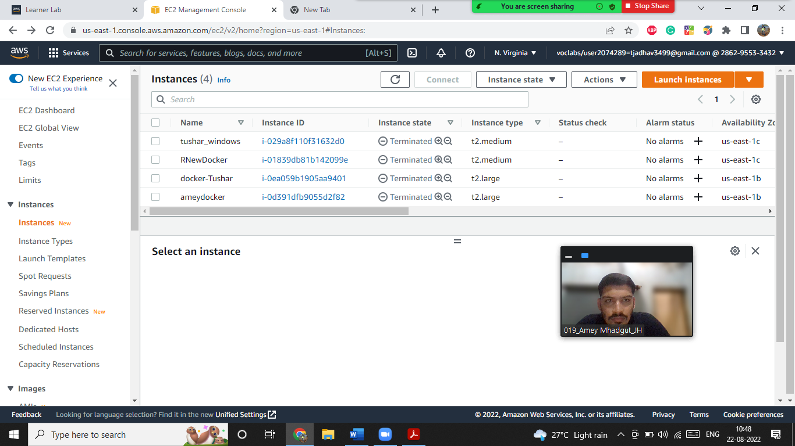

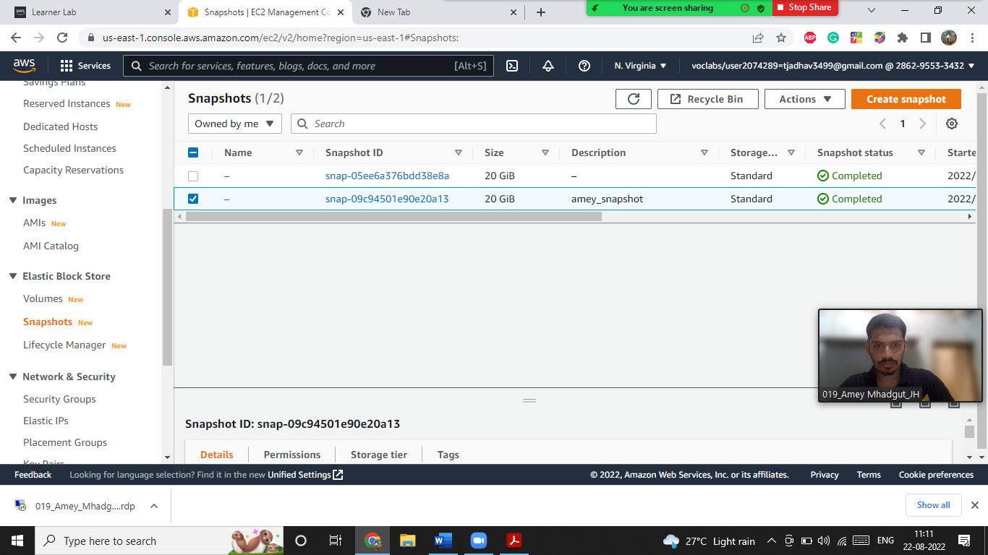

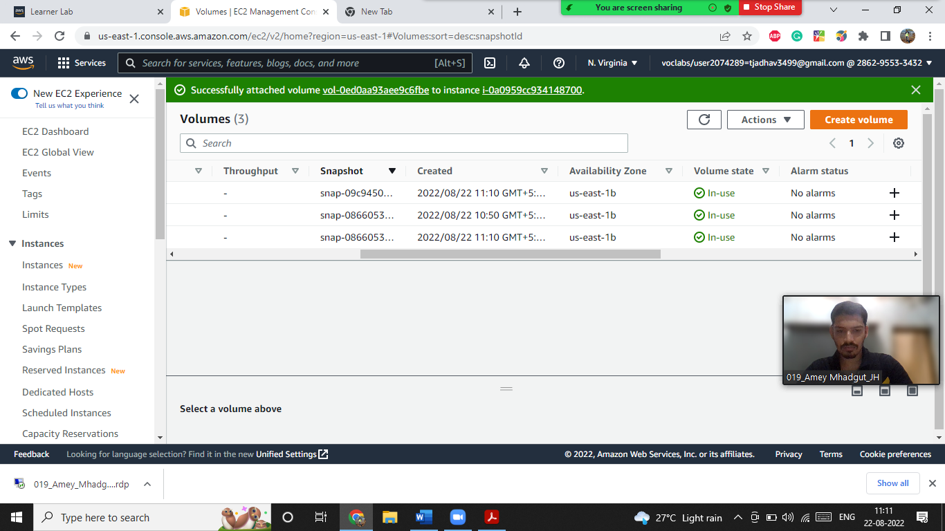





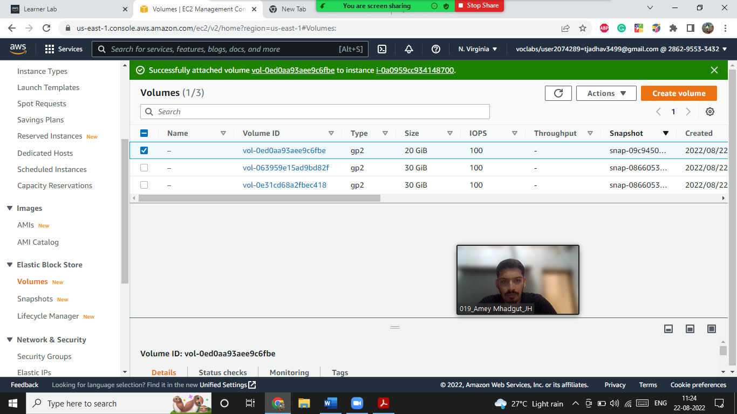

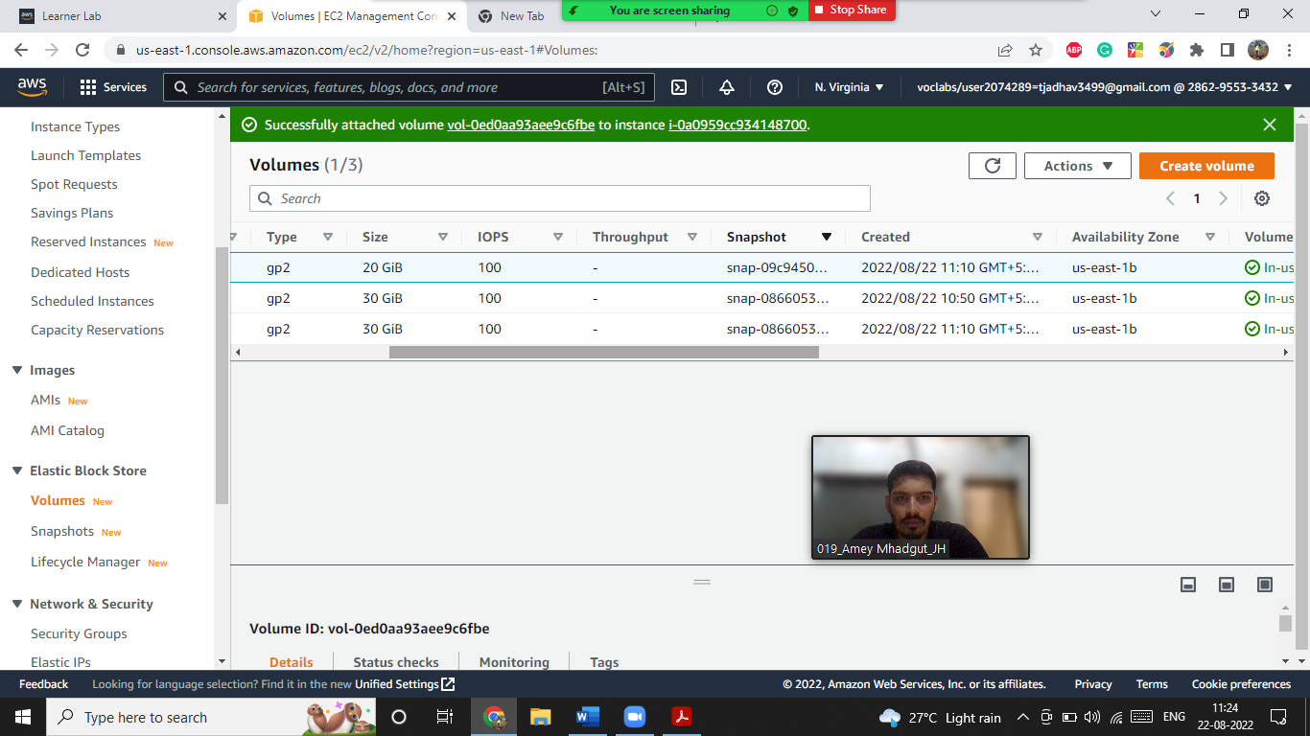



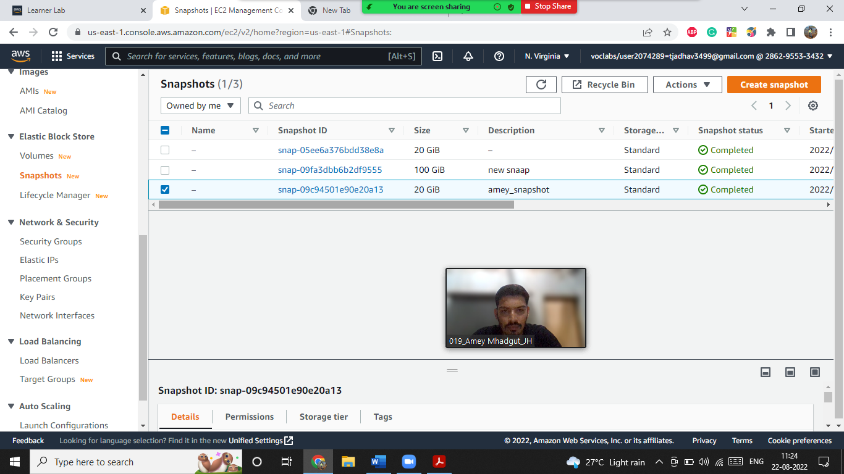

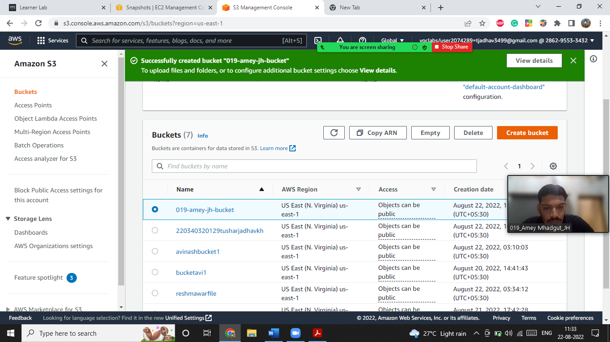

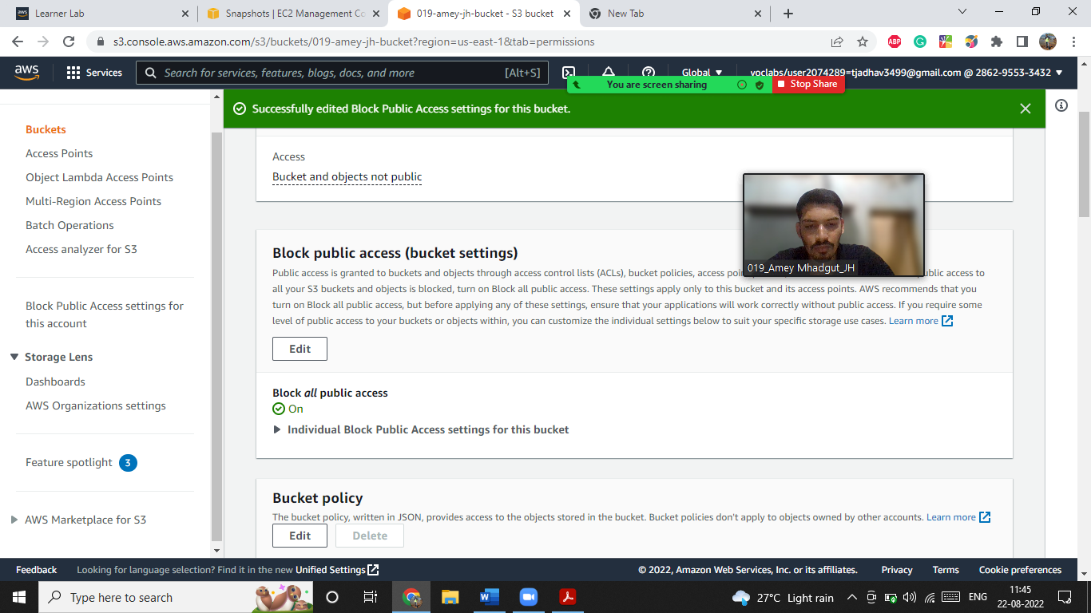

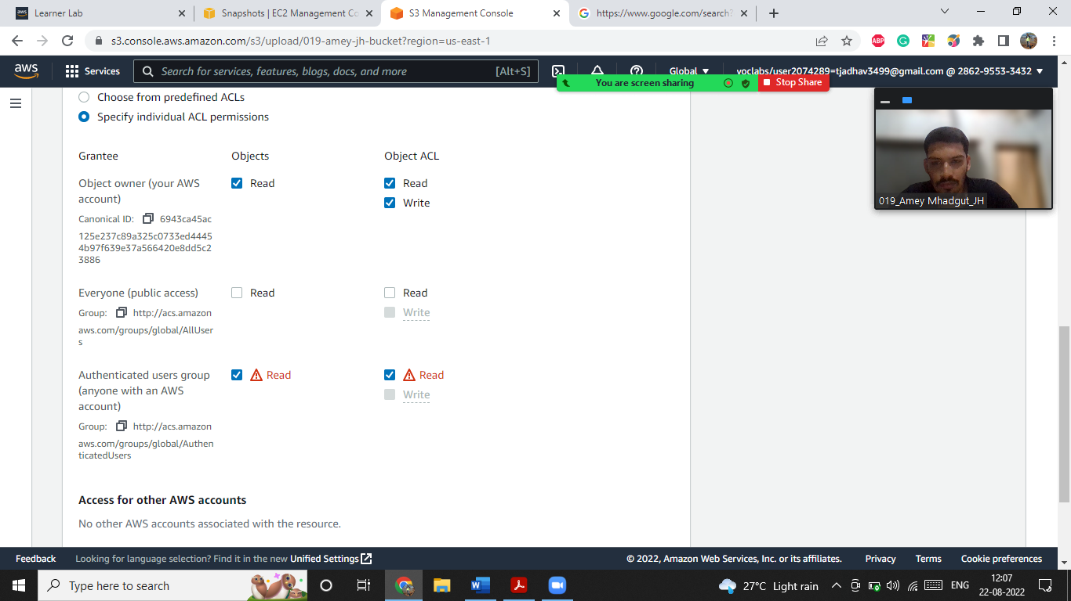

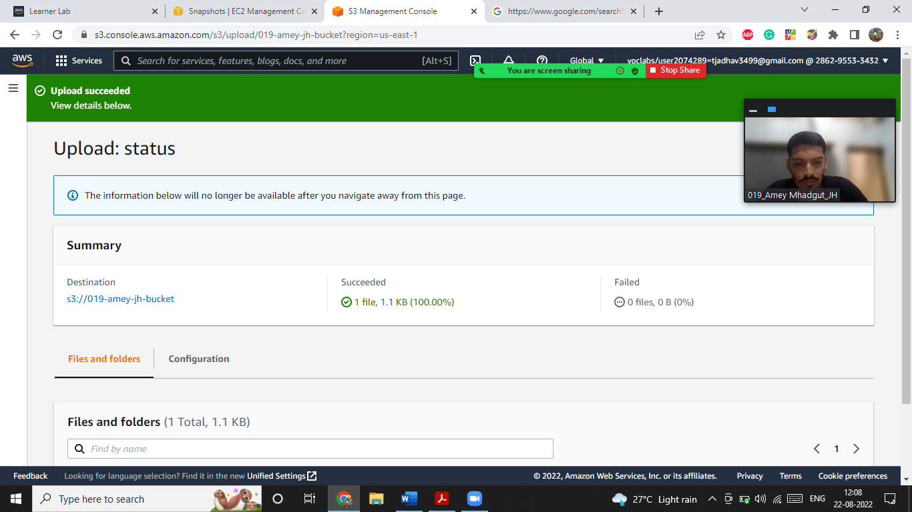

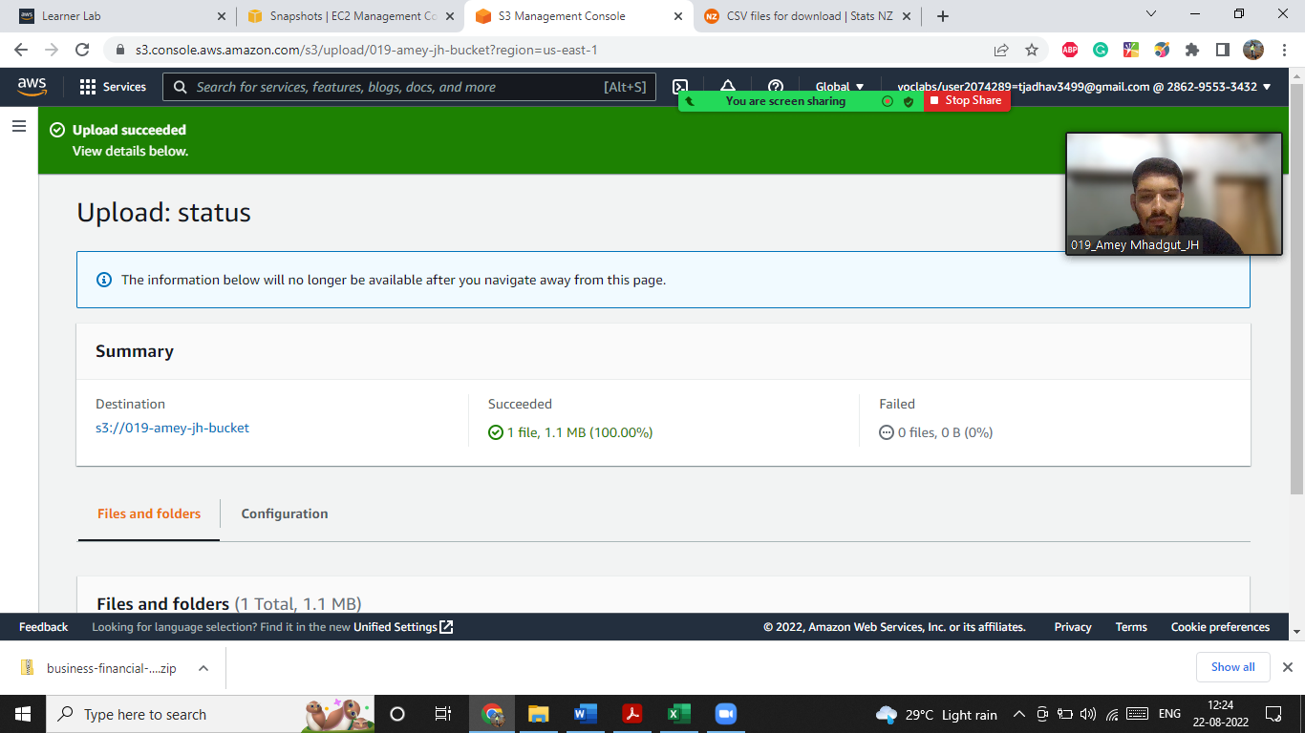

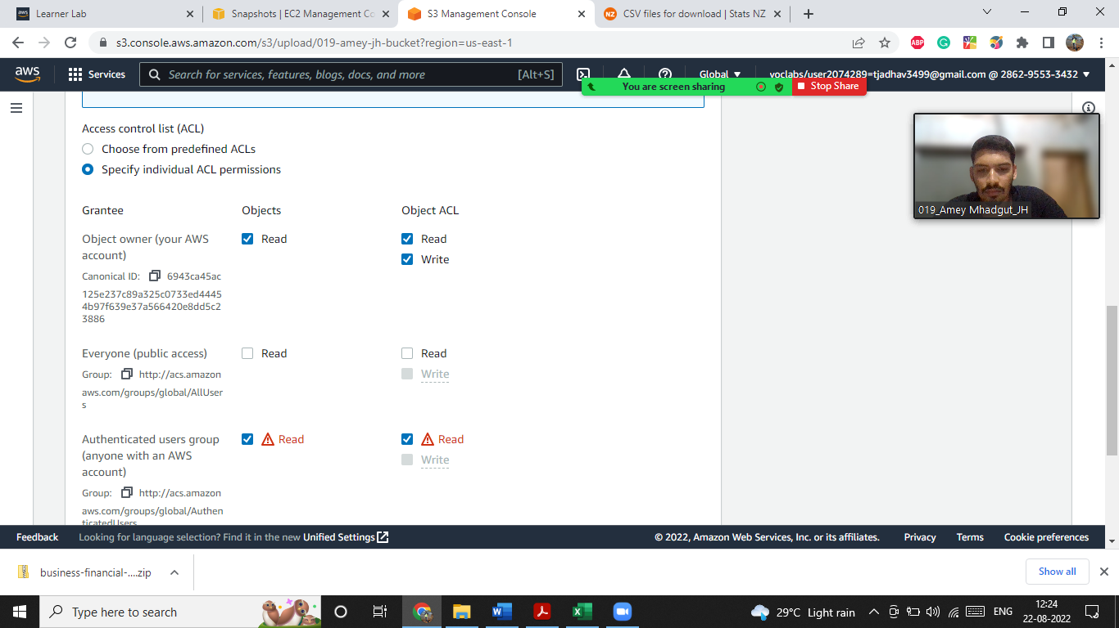

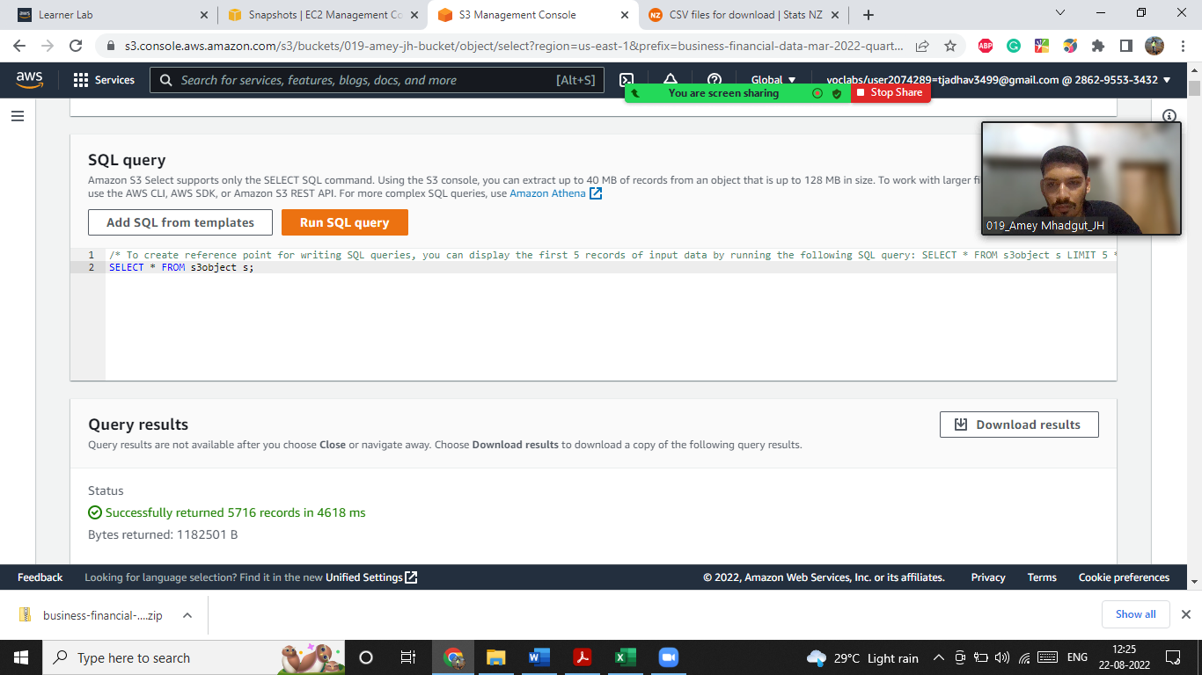

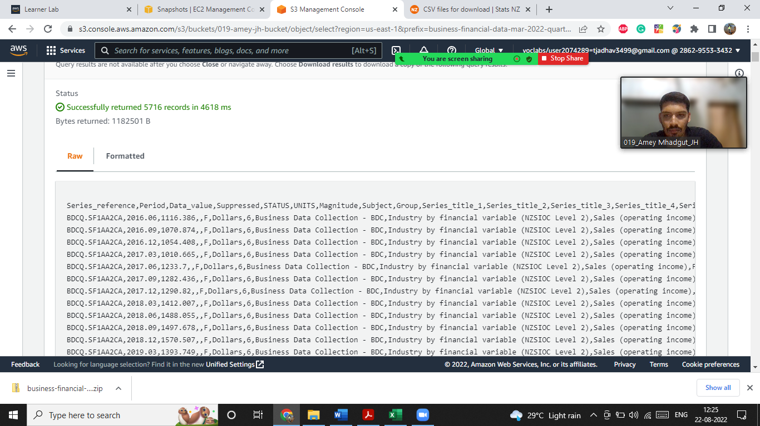

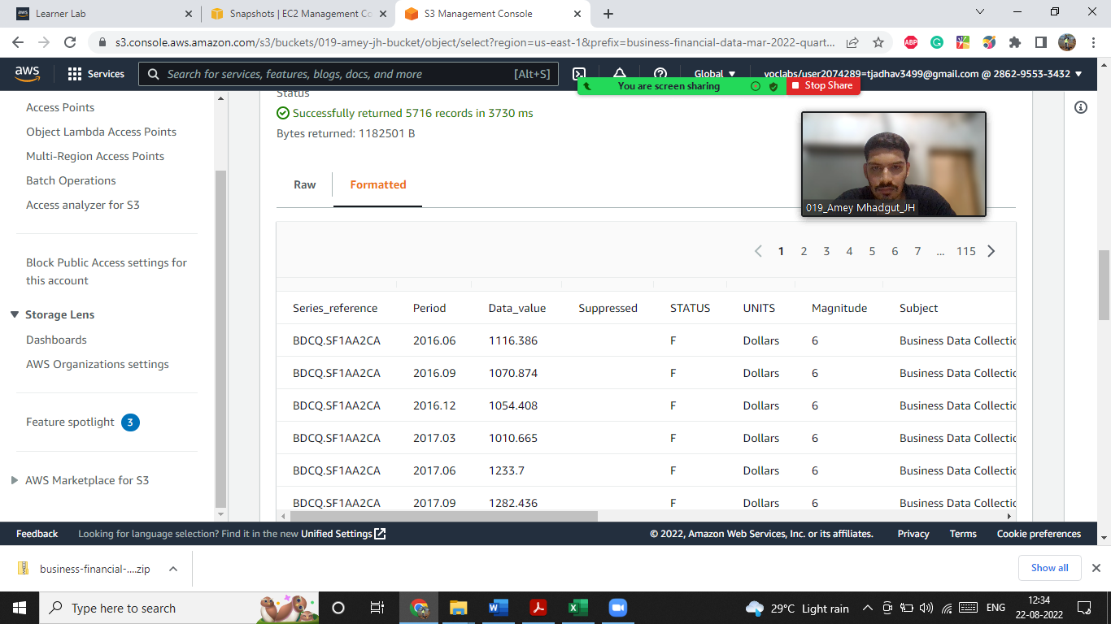

Theory

Q1.Describe the role of the Amazon S3 service in big data solutions.

Ans->The most secure,durable and scalable storage to build your data lake.

Build your data lake into Amazon S3. It is the largest and most performant object storage service for structured and unstructured data and storage choice to build a data lake.

With a data lake built on Amazon S2,you can use native AWS security

to run big data Analytics,AI,ML,HPC and media data processing.

Q2. Explain how AWS Identity and Access Management (IAM) controls access to Amazon S3.

Ans->AWS identity and Access Management(IAM) is a web service that helps you securely control access to AWS resources. We can use IAM to control who is authenticated (signed in) and authorised (has permissions) to use resources. IAM gives us features like Granular permissions,secure access to AWS resources for applications that run on Amazon EC2,Multi-Factor authentication,identity information for assurance.